Lab 11: Data Structures and Algorithms

**Topic: BST Continued**

# Objective

* Working on the Binary Search Trees

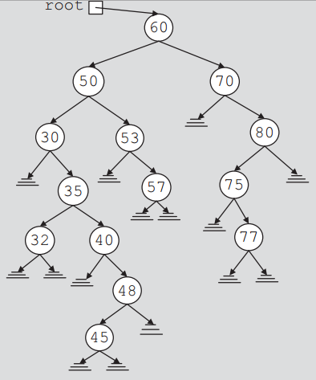**Task 1:**

Write the code of insertion into a BST. Using your code, create the binary tree (given on the right).

## Task 2:

Write SIX recursive codes for traversing a BST. The function names should be:

* LNR
* RNL
* RLN
* LRN
* NLR
* NRL

Write the output for all kinds of traversals as comments in your main program.

## Task 3:

Write down a function that takes the pointer to the root of the binary tree as an input parameter and returns the height of the tree. OPEN THE BOOK AND READ ABOUT HEIGHT OF THE TREE, UNDERSTAND AND IMPLEMENT.

Test your function on the tree from Task 1 and the tree given below:

